**Logo NFB of Florida logo
**

# 2024 STATE CONVENTION

***“BUILDING TOMORROW TOGETHER”***

**Friday through Sunday,**

**November 8 - 10, 2024**

**The Southbank Hotel and Conference Center,**

**(a Marriott Bonvoy property)**

**1515 Prudential Dr.**

**Jacksonville, FL 32207**

**904-396-5100**

**Please Note: This agenda is subject to change at any time without notice.**

# NFB PLEDGE

**I pledge to participate actively**

**In the efforts of the National Federation of**

**the Blind**

**To achieve Equality, Opportunity,**

**And Security for the blind;**

**To support the policies and programs of the**

**Federation;**

**And to abide by its constitution.**

# Important Convention Information

**You must be registered for the Convention to WIN door prizes.**

**Door prizes will be awarded at general sessions and the banquet. You must be PRESENT in the session or on approved National Federation of the Blind of Florida business to receive a door prize.**

**Please turn in Dolla’ auction items and door prizes at the NFB of Florida Registration Desk in the Propeller Room, Friday, November 8th from 3:30 - 6:30 or contact Peggy Fleischer at 386-931-2132.**

# COVID POLICY

Masks are optional at our convention. If any attendees wish to wear a mask, they may feel free to do so. The National Federation of the Blind of Florida will follow the hotel’s policies. We will additionally follow any guidelines mandated by the Centers for Disease Control (CDC) and local, state, or federal entities that may be enacted up until the close of our convention.

**Note**: This policy is subject to change based on hotel policy, local, state, or federal regulations that may be placed in effect at the time of our convention.

# INCLUSIVITY, DIVERSITY, AND CODE OF CONDUCT

We are committed to providing a welcoming, safe, and healthy environment for everyone. Thank you for cultivating an atmosphere of mutual respect in which participants from diverse backgrounds can learn, network, and share with each other. We are committed to diversity, equity, and the free expression of ideas. These principles have been outlined in our Code of Conduct found at https://nfb.org/codeofconduct.

We recognize a shared responsibility to create and uphold that atmosphere for the benefit of all. Prohibited behaviors include harassment and sexual misconduct. Prohibited behavior will not be tolerated and may result in removal from the convention and/or other consequences. For assistance or to report an incident at the convention, please call 410-659-9314, extension 2475, or email code@nfb.org. Formal reports can be submitted at https://www.nfb.org/about-us/history-and-governance/code-conduct/code-conduct-complaint-report-form. All formal reports will be fully investigated according to the steps in our Code of Conduct. For support or guidance, connect with our survivor-led task force at survivors@nfb.org or extension 2238. Thank you for your commitment to the safety and support of the blind community.

# Privacy Notice

This is a public event. You may be filmed on video or captured in photos that may be published in media outlets, including Mastodon, X, Facebook or other social media sites. Some sessions and activities at the 2024 National Federation of the Blind of Florida State Convention may be photographed or videotaped. By participating in the State Convention, registrants agree that The National Federation of the Blind of Florida has the right to use their image, likeness and/or voice or sound recording taken in connection to the State Convention in all media.

# Presidential Suite - TBA

By appointment – Please make appointments by contacting President Hernandez at 305-877-2311 or [President@NFBFlorida.org](mailto:President@NFBFlorida.org).

# Hospitality Suite – Room 125

Friday, November 8th, 3:00pm - 7:00pm

Saturday, November 9th, 7am - 8:45am & 12:00pm - 6:00pm

Sunday, November 10th, 7am - 8:45am & 12:00pm - 5:00pm

# Exhibit Hall – Starboard Ballroom

Russ Davis, Exhibit Hall Coordinator

Friday, November 8th, 12:00pm – 7:00pm

Saturday, November 9th, 12:00pm – 6:00pm

Sunday, November 10th, 12:00pm – 5:00pm

# Registration – Propeller Room

Sylvia Young, Treasurer

Friday, November 8th, 3:30pm – 6:30pm

Saturday, November 9th, 8:00am – 8:45am

Sunday, November 10th, 8:00am – 8:45am

# The Big Red Bus - Rope Room

Friday, November 8th, 12:00pm – 6:00pm

Saturday, November 9th, 12:00pm – 6:00pm

Sunday, November 10th, 12:00pm – 5:00pm

Appointments are encouraged, visit oneblood.org/donate. ID REQUIRED.

# Jacksonville Speech and Hearing Center

free hearing evaluations

located in the rear parking lot near the Exhibit Hall for, Saturday, November 9th, 12:00pm – 6:00pm

Sunday, November 10th, 12:00pm – 5:00pm

# Tactile Art Show and Sale - Bridge Foyer

Friday, November 8th, 3:30pm – 6:30pm

Saturday and Sunday, 12:00pm – 6:00pm in Exhibit Hall

# Schedule of Convention Events

## Friday, November 8, 2024

12:00pm - 7:00pm Exhibit Hall - Starboard Ballroom Russ Davis, Coordinator

National Federation of the Blind of Florida

3:30pm - 6:30pm Tactile Art Show and Sale

Bridge Foyer

Vicky Lennon, National Federation of the Blind of Florida, Greater Jacksonville Chapter member

### 3:30pm - 6:30pm Convention Registration

Propeller Room

Sylvia Young, Treasurer, National Federation of the Blind of Florida

### 4:00pm - 5:00pm Volunteers & Talking Signs

### Meet-up

Hotel Lobby

Doug Ingram, Ambassadors Committee Chair, National Federation of the Blind of Florida

5:00pm Guided Hotel Tour

Led by Doug Ingram

Hotel Lobby

5:00pm - 7:00pm Mix & Mingle

Members & Exhibitors

Windward andStarboard Ballrooms

### 6:00pm – 7:00pm Rookie Round-up

Port Ballroom

Jorge Hernandez, President, National Federation of the Blind of Florida

### 7:00pm - 7:50pm Resolutions Committee

Port Ballroom

Camille Tate, Chair, Resolutions Committee, National Federation of the Blind of Florida

### 8:00pm - 9:00pm Open Board Meeting

Port Ballroom

Jorge Hernandez, President, National Federation of the Blind of Florida

### 9:00pm – Until Students Social - Networking

Tug Room

Z’Leah Liburd, President, Florida Association of Blind Students

## Saturday, November 9, 2024

### 7:30am - 8:45am Devotions

Tug Room

The Blind Christians Group

### 8:00am - 8:45am Convention Registration

Propeller Room

Sylvia Young, Treasurer, National Federation of the Blind of Florida

## General Session I

9:00am to 12:00pm

Port Ballroom

### 9:00am Call to Order

Jorge Hernandez, President, National Federation of the Blind of Florida

### 9:05am Invocation

Jody Rice, Pastor, St Andrews Lutheran Church By The Sea

### 9:10am Pledge of Allegiance

Jeffery Davis, Vice President, Tallahassee Chapter, National Federation of the Blind of Florida

### 9:13am National Anthem

Z’Leah Liburd, President, Statewide Chapter, National Federation of the Blind of Florida

### 9:16am National Federation of the Blind

### Pledge

Alexandra Diggs, Treasurer, Tallahassee Chapter, National Federation of the Blind of Florida

### 9:18am National Federation of the Blind

### One Minute Message

Carrie Renwick, Tallahassee Chapter, National Federation of the Blind of Florida

### 9:20am Welcome Host Chapters

Kaye Baker, President, Greater Jacksonville Chapter and Donald Christie, President Tallahassee Chapter

### 9:30am Welcome from the City of Jacksonville

Kara Tucker, Chief of Disabled Services Division, City of Jacksonville, Florida

### 9:40am Jacksonville Transportation Authority

Greer Johnson Gillis, P.E. Senior Vice President, Chief Infrastructure and Development Officer

### 9:55am National Report

Everette Bacon, National Rep, Second Vice President, National Federation of the Blind

### 10:30am Report from the Bureau of Braille and Talking Book Library

Nicole Saunders

### 10:45am What's happening at AIRA

Everette Bacon, National Rep, Second Vice President, National Federation of the Blind

### 11:00am Better Business Enterprise

Food Services, Inc. of Gainesville

recorded audio message

### 11:15am Florida School for The Deaf and The Blind

### 11:45am Acknowledgements and announcements

### 12:00pm Adjournment

### 12:00pm - 1:00pm Lunch - On your own

Grab and Go lunches available in lobby-$16 cash only

### 12:00pm - 12:45pm Treasurers Lunch

Navigator

Sylvia Young, Treasurer

National Federation of the Blind of Florida

### 12:00pm - 6:00pm Exhibit Hall – Starboard Ballroom

### 12:00pm - 6:00pm Hospitality Suite Room 125

### 12:00pm – 6:00pm The Big Red Bus

## Saturday Special Interest Meetings and Workshops

**1:00pm to 5:00pm**

### 1:00pm - 2:50pm Deaf-Blind Division Annual Meeting

Port Ballroom

Marilyn Baldwin, President, Deaf-Blind Division of Florida

Living with the dual sensory loss of hearing and vision.

### 1:00pm - 1:50pm Meet the 2024 Florida Leadership Class

Anchor Room

Camille Tate, First Vice President, National Federation of the Blind of Florida

Come and meet the graduates of our 2024 Florida leadership seminar! Hear about their experiences and what they learned. Ask all the questions you could ever think of and learn about our wonderful organization.

### 2:00pm - 2:50pm What's happening with AIRA

Sail Room

Everette Bacon, National Rep, Second Vice President, National Federation of the Blind

Check to hear the latest news from AIRA! See what exciting changes or updates are coming along the way. Ask your questions about AIRA and discuss the ins and outs of the service.

### 2:00pm - 2:50pm Reading Roundup

Tug Room

Russ Davis, Board Member National Federation of the Blind of Florida

Books, BARD, and so much more! Join us for a lively discussion on the joys of reading. Come ready to share not only what you’re reading but how you’re making it happen. There’s BARD and Bookshare and so much more.

### 3:00pm - 3:50pm ABLE United

Sail Room

Karen Prewitt

It's more than saving. It's investing for a better life.

### 

### 3:00pm - 3:50pm Adjustment to Blindness

Tug Room

Camille Tate and Russ Davis, National Federation of the Blind of Florida

New to blindness? Let's have a conversation with each other on what works for us and how we can travel this journey together.

### 3:00pm - 3:50pm Harnessing the Power of Meta Glasses and AI

Anchor Room

Peggy Fleischer, , Board Member National Federation of the Blind of Florida

Bob Schrepfer, The Magnification Company, President

AI is the newest buzzword in the technology arena. Find out how harnessing the power of AI can work in your daily life and how using a pair of the new Meta Glasses can take your AI experiences to the next level.

### 4:00pm - 4:50pm FABS Annual Business Meeting

Tug Room

Z’Leah Liburd, President, Florida Association of Blind Students

### 4:00pm - 4:50pm FLAGDU Re-Vamp

Sail Room

Scott Siegle, Broward Chapter

Interested in a guide dog? Have questions only another guy dog user can answer? Come and join this workshop to gain interest in re-booting our FLAGGU division.

### 4:00pm - 4:50pm Dress for Success, Dress with No Stress

Anchor Room

Shannon Harvey, The Men’s Warehouse

Ever wondered what to wear for work or interviews? How about for a casual day out with family and friends? Shannon from The Men's Warehouse will be here to share what works best for all occasions!

### 5:00pm Florida Statewide Chapter Annual Business Meeting

Tug Room

Z’Leah Liburd, President, Florida Statewide Chapter

### 5:00pm - 7:00pm Dinner - on your own

### 7:00pm Dolla’ Auction

Windward Ballroom

Auctioneers James Jacobs & Sarah Jacobs, Greater Jacksonville Chapter, National Federation of the Blind of Florida

Bring your dollar bills! We are having a Dolla’ Auction! How does it work? Make sure you bring your singles and let the fun begin! Each item in this auction will go one dollar at a time. If you see an item you like, hold up your buck and say your name “got a dollar”. We will take your dollar but wait…others can bid a dollar against you, so pay attention!

## Sunday, November 10, 2024

### 7:30am - 8:00am Devotions

Tug Room

The Blind Christians Group

### 8:00am - 8:45am Nominating Committee

**Delegates only**

Sail Room

Miranda Kilby, President, Tampa Bay Chapter

### 8:00am - 8:45am Convention Registration

Final Opportunity!!

Propeller Room

Sylvia Young, Treasurer, National Federation of the Blind of Florida

## General Session II

9:00am - 12:00pm

Port Ballroom

### 9:00am Call to Order

Jorge Hernandez, President, National Federation of the Blind of Florida

### 9:01am Invocation

John Johnson, Vice President, Miami Dade Chapter

### 9:05am Why I am a Federationists

Jada Michael-Christie, Member of Tallahassee Chapter

### 9:10am President’s Report

Jorge Hernandez, President, National Federation of the Blind of Florida

### 9:30am Treasurer’s Report

Sylvia Young, Treasurer, National Federation of the Blind of Florida

### 9:45am Resolutions Committee Report

Camille Tate, Chair, Resolutions Committee

### 10:10am ABLE United

Karen Prewitt

Brand Ambassador

### 10:20am Charter-Spectrum Communications

Petr Kucheryavyy, Senior Manager, Accessibility Center of Excellence

### 10:30am Division of Blind Services

Robert Doyle, Director

### 10:55am Nominating Committee Report

Miranda Kilby, President, Tampa Bay Chapter

### 11:00am Elections

### 11:55am Announcements & Adjournment

### 12:00pm - 1:00pm Lunch - On your own

Grab and Go lunches available in lobby-$16 cash only

### 12:00pm - 12:50pm Secretaries’ Lunch

Navigator

Kaye Baker, Secretary, National Federation of the Blind of Florida

### 12:00pm - 5:00pm Exhibit Hall – Starboard Ballroom

### 12:00pm - 5:00pm Hospitality Suite Room 125

## 

**12:00pm – 5:00pm The Big Red Bus**

## Sunday General Interest Meetings and Workshops

**1:00pm to 5:00pm**

### 1:00pm - 1:50pm Resume Building with AI

Anchor Room

Jorge Hernandez, President, National Federation of the Blind of Florida

Ever wonder what to write in your resume? Unsure what makes a resume catch the attention of employers? Join us to find out how Chatt GPT can help create a stand-out resume.

### 1:00pm - 1:50pm Diversity and Inclusion

Sail Room

Coming together after the election. With voting behind us for the 2024 general election, it's the perfect time to discuss how we can all still work together in a respectful and effective way on the issues we have in common.

### 1:00pm - 1:50pm Self-Advocacy

Tug Room

Camille Tate, First Vice-President, National Federation of the Blind of Florida

Advocating for Ourselves. How do we best advocate for ourselves? When is the right time to assert our rights and how can we educate the public on the courtesies when meeting a blind person for the first time? Come and learn some of the best practices for self-advocacy, from asking for assistance to refusing the wheelchair at airports. We are the experts in what we need, so let's hear how we can best advocate for ourselves.

### 2:00pm - 3:50pm Legislation

Port Ballroom

Russ Davis, Legislative Director

Camille Tate, Legislative Director

Your Florida Legislative Directors will lead a crucial discussion on the importance of voting and how our voices must be heard. We’ll also cover in detail NFB of Florida’s specific legislative priorities for 2025. Find out more about plans our to march on Tallahassee early next year.

### 2:00pm - 2:50pm Sighted Supporters Meeting

Tug Room

Sylvia Young, Treasurer, National Federation of the Blind of Florida

## Do you ever wonder where the supporter gets support. Join us in this open discussion among sighted federation members who support and encourage our blind federation family and friends to live the life they want. Special Guess, Jada Michael Christie.

### 3:00pm - 3:50pm Job Search Resources

Sail Room

Kaye Baker, Secretary, National Federation of the Blind of Florida

Searching for employment? Where can you seek your new career? There are many tools available at your fingertips to find your dream job. Come to find the most accessible places to jump start your career.

### 3:00pm - 3:50pm Audio Description at Your Fingertips for Free

Anchor Room

Petr Kucheryavyy, Charter-Spectrum Communications

### 4:00pm - 4:50pm President’s Reception

Navigator Room

Jorge Hernandez, President, National Federation of the Blind of Florida

The presidents and vice-presidents are invited to a reception with Everette Bacon, National Rep, Second Vice President of the National Federation of the Blind.

## Convention Banquet

## Sunday, November 13, 2024

7:00pm - 10:00pm

Miranda Kilby, Mistress of Ceremonies

Port and Windward Ballrooms

### 7:00pm Call to Order

Jorge Hernandez, President, National Federation of the Blind of Florida

### 7:05pm Introduction of Head Table

Miranda Kilby, President of Tampa Bay Chapter, Mistress of Ceremonies, National Federation of the Blind of Florida

### 7:10pm Invocation

Joyce Taylor, President, Melbourne Space Coast Chapter

### 7:15pm Keynote Address

Everette Bacon, National Rep, Second Vice President, National Federation of the Blind

### 8:00pm Remembering our Lost Members

Judith Hamilton, President, Gainesville Chapter

### 8:15pm Presentation of Scholarship

### Winners

Denise Valkema, Second Vice President, Chair, Scholarship Committee, National Federation of the Blind of Florida

### 8:45pm Awards Presentation

Peggy Fleischer, Board Member, Convention Chair, National Federation of the Blind of Florida

### 9:45pm Raffles and Drawings

### 10:00pm Adjournment

# Convention Sponsors and Exhibitors

## Title Plus Sponsor

**Charter Spectrum**

## Title Sponsors

**ABLE United**

**Food Services Inc of Gainesville**

**The Magnification Company**

**Vanda**

## Equality Sponsors

Democracy Live Inc

Patriot Vision Industries

## Security Sponsors

Blind Girl Design

Enhanced Vision Systems

Florida Reading & Vision Technology

Friends of Library Access Inc

GuideLights Solutions, Inc

Odham Opals and Gems

## Non-Profit Exhibitors

Florida Association of Blind Students

Florida Statewide Chapter

Greater Jacksonville Chapter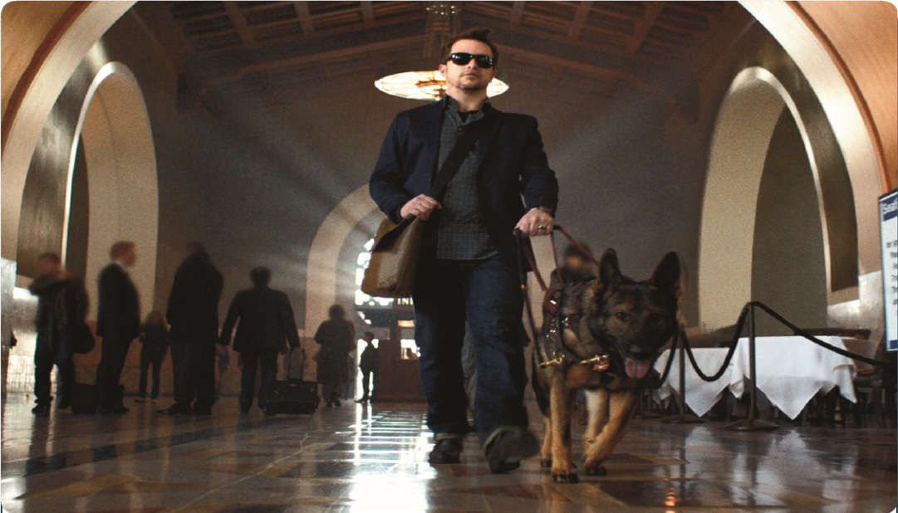**Vanda Pharmaceuticals**

**Vanda pharmaceuticals is dedicated to raising the awareness of Non-24-Hour Sleep-Wake Disorder (Non-24) and supporting the blindness community.**

**Non-24 is a rare circadian rhythm disorder affecting up to 30% of totally blind individuals. People living with Non-24 experience excessive daytime sleepiness, nighttime sleeplessness which leads to impaired social and occupational function due to misalignment of the internal master body clock to the 24-hour day, disrupting the sleep-wake cycle.**

**Come visit us at our booth to learn more about Non-24**

**and sign up for additional information**

**Call a health educator toll free at 1-855-856-2424, 24 hours a day**

**NON-24**

**A circadian rhythm disorder**

**Visit us online at** [**www.non-24.com**](http://www.non-24.com)

Able United Logo  Save for a better life experience

**It's more than saving. It's investing for a better life.**

An ABLE United account gives Floridians with a disability a tax-free way to save while protecting public benefits.

**Ableunited.com**

*Eligible individuals will have a diagnosis of blindness or visual impairment with onset prior to age 26. The term “blind” means that the individual has central visual acuity of 20/200 or less in the better eye with the use of a correcting lens. An eye which is accompanied by a limitation in the fields of vision such that the widest diameter of the visual field subtends an angle no greater than 20 degrees is considered to have a central visual acuity of 20/200 or less.*

**Contact Us or Call 1-888-524-ABLE (2253)**

**Website: https://www.ableunited.com/**

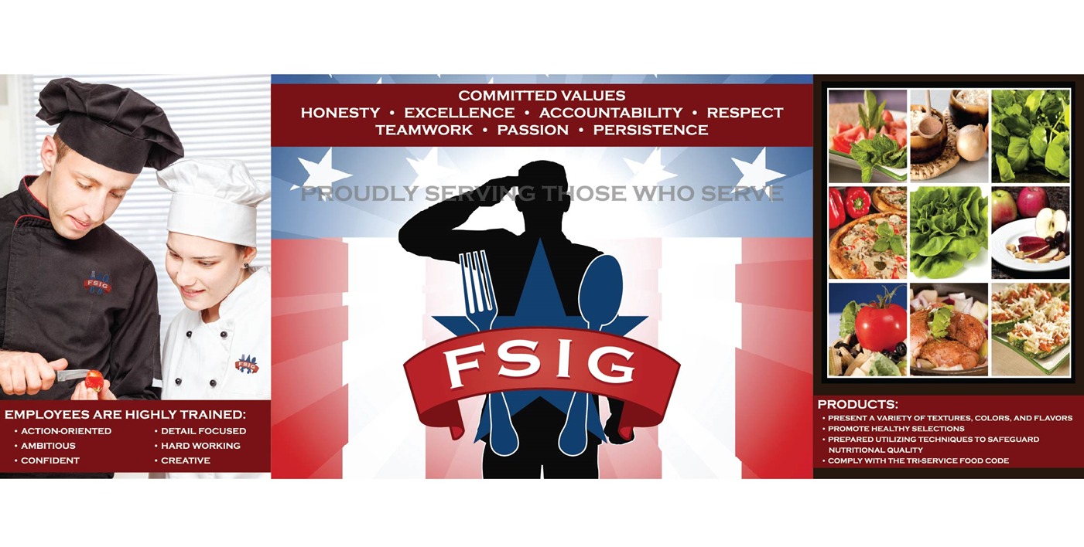FSIG works with state agencies to graduate legally blind vendors into independent entrepreneurs.

FSIG provides legally blind vendors the technical expertise, training, and all necessary financial resources to obtain and

operate government contracts with no personal risk.

621 Washington Street, Suite 7A, Gainesville, GA 30501

Tel: 770-535-8865 Fax: 770-532-7627

[www.fsigonline.com](http://www.fsigonline.com)

## Southbank Hotel by Marriott-Description

**Products for the Blind and Visually Impaired**

PATRIOT VISION INDUSTRIES LLC, nestled in the rolling hills of central Florida, proudly designs, manufactures and distributes innovative assistive technology under our PATRIOT brand.

Pioneers in the industry, we continually strive to empower our customer's lives with our award winning products and improve the quality of life for those we serve.

Patriot is the brand you can trust. Please call today to schedule a demonstration with one of our authorized dealers in your area, worldwide, or to receive more information or place your order!

For nearly 30 years, Patriot is the name brand you can trust for a sight to be seen.

**1-800-364-1608**

**info@patriotvision.com**

In too many states, voters with disabilities don’t have equal access to voting independently and privately from home. Fortunately, there are new accessible at-home voting technologies now available.   
The Democracy Live OmniBallot accessible at-home voting system is a fully ADA Section 508, WCAG 2.2AA compliant remote ballot marking solution. The system has been tested to meet the accessibility requirements of over 90 combinations of browsers, operating systems, screen readers and devices. OmniBallot has been deployed as an accessible absentee tool since 2008, in over 5,000 elections, serving more than 2,500 jurisdictions, in 34 states and 96 countries around the world. OmniBallot has been tested and reviewed by members of most every leading disability organization in the nation.

For further information, please contact Democracy Live:

855-655-VOTE (8683) Toll Free   
Email: info@democracylive.com www.democracylive.com

## 2024 National Federation of the Blind of Florida

## State Convention

The Greater Jacksonville and Tallahassee Chapters of the National Federation of the Blind of Florida are ready to welcome you to our 2024 State convention at the Southbank Hotel.

Built in 1981, the Southbank Hotel is nestled on the south bank of the St Johns River and boasts convenience to both the San Marco and Riverside neighborhoods. The hotel has many amenities including an outdoor pool, fitness center and on-site bar and restaurant. The hotel has been recently renovated and draws inspiration from the many ports and bridges around Jacksonville.

As we enter the hotel’s entrance, we find ourselves in a spacious lobby. The lobby area is shaped like a rectangle, with the entrance and elevators on the short sides of the rectangle, and the check-in area and bar along the long sides. If we were to walk straight upon entering the lobby we would come to a seating area with several couches and tables. This area can be best identified by the carpeting on the floor. The carpet is a great landmark to help us find the check-in desk, so after entering the main entrance, we will walk straight until we encounter the carpet, then make a right. Follow the carpet until it ends, then continue walking straight, and the check-in counter will be right in front of us. Immediately to the right of the counter is an ATM machine.

If we place the counter on our right and continue walking straight, the next area we come to will be a vending area. Here, items such as snacks, Starbucks coffee, sodas and other sundries can be purchased. Note, the machine used to purchase the items is currently not accessible, so a member of the hotel staff, friend or volunteer will be happy to assist.

Making a right immediately after the check-in counter ends will lead down a long hallway which has the fitness center on the left, and a vending machine containing medical supplies such as pain relievers and masks.

Continuing past the vending area will bring us to a water station on the right. The water station is a table with a water cooler and cups sitting on it. There is also a trash can directly to the left of the water station so that any used cups can be discarded.

Once we come to the end of the water station, there will be a column on the left. This column is a good indicator that the hallway that leads to the elevators is coming up soon. Turning right at the next hall, will lead into the hallway that holds both the elevators and Convention center. The elevators are to the left, and convention center to the right.

For now, lets return to the main entrance, and explore the other side of the lobby. This time, from the entrance, we will again go straight until we get to the carpet, but instead of a right, we will turn left. Walk until the carpet ends on the right and turn right again. Johnny’s bar will be immediately on the left.

If we continue past Johnny’s and walk until the wall on our left side ends, the hotel restaurant will be straight ahead. The restaurant currently is open for breakfast only.

If we pass Johnny’s and make a left when the wall ends, we will enter an area that has a pool table and a foosball table. Going straight will take us to an exit door. This door can be used to get to one of the dog relief areas.

For this exit door, a room key is not needed. Once we have exited the hotel, we will continue to walk straight until we reach a sidewalk. Make a right on the sidewalk and keep walking straight. One great landmark is the sound of the air conditioning units. Once we hear the AC units we know the dog relief area is on the right. A trash can with baggies is also being provided. To find this continue down the sidewalk until it veers to the left. Once the sidewalk turns, start checking on the right for the trash can and bag stand.

Now that we are back in the hotel, lets check out the convention center area. Remember that if we enter the hallway just after the water station, the elevators will be on the left, and the convention center on the right. The convention center is shaped like a crescent, with 3 entrances. When we first enter the convention center, we will find ourselves in the pre-function registration area. This is where we will hold convention registration. Making a right here will take us down a long hall with meeting rooms on the right, and seating on the left. The first meeting room we come to is Anchor, followed by Rope. After Rope is an open area with hallways that lead to the hospitality suite, the pool, and the second dog relief area. If we turn right here, we will come to some restrooms, and an exit that leads out to the pool. If we make a left instead of a right, we will come to a hall with some suites, including our hospitality suite and an exit. Using this exit to get to the second dog relief area will require a room key.

However, if we continue going straight through the open area and down the hallway, we will come to a dead end. If we make a left here, there will be windows on the right, and Port Ballroom on the left. Port is where our General Session will be held. The next room is Winward which is where the auction will be held. Starboard is next which is where our exhibit hall will be.

Remember that when we were in the pre-function area, we made a right to get to the meeting rooms. Now let’s go back to the pre-function area and make a left. Doing this will bring us to a hallway with meeting rooms on either side. The first room on the right is Tug, on the left are Rigging and Sail. There are two final rooms that should be mentioned. They are just outside of the pre-function area. If we are coming from the elevators and walking straight, they will be on the right. Those rooms are called Commerce and Dockside.

Now that we have finished our tour of this great hotel, it is time to get ready for an awesome state convention. Remember that if you get a little lost listen for the talking signs. We will have talking signs and ambassadors throughout the hotel to assist whenever needed.

Also, don’t hesitate to reach out to either of the host chapters or the state board with any questions or concerns.

### Nearby Pharmacies:

Publix Pharmacy

Publix – Shops at East San Marco

2039 Hendricks Ave.

Jacksonville, FL. 32207

Distance from hotel = 1.5 miles

(904) 523-7317

### Nearby Veterinary Hospitals:

San Marco Animal Hospital

1546 San Marco Blvd.

Jacksonville, FL. 32207

Distance from hotel = 0.9 miles

ph. 904-516-9767

open 7 days per week

**After hours Emergency Veterinarian**

Blue Pearl Animal Hospital

3444 Southside Blvd. Unit #103

Jacksonville, FL. 32216

Distance from hotel = 7.4 miles

ph. 904-642-5911

## National Federation of the Blind of Florida

## Officers and Board of Directors

Jorge Hernandez, President

Camille Tate, First Vice President

Kaye Baker, Secretary

Sylvia Young, Treasurer

**Board of Directors:**

Russ Davis

Peggy Fleischer

Douglas Ingram

The National Federation of the Blind of Florida thanks the Jacksonville and Tallahassee Chapters, the Convention Planning Committee, and everyone who assisted for their dedication and hard work organizing the 2024 state convention. We thank all of our members for joining and supporting us here in Jacksonville. Florida. We acknowledge all our sponsors for their generous donations, as well as everyone who contributed to the development process to make our convention a great success. We look forward to continuing to work with all of you in 2025.

Let’s go build the Federation!

Sincerely,

Jorge Hernandez, President

National Federation of the Blind of Florida

## Chapters, Divisions, Committees, and Groups

### President*:*

State Affiliate – Jorge Hernandez, (305) 877-2311, president@nfbflorida.org

### **Chapters**:

Greater Broward - Jake McEntyre, (954) 946-4148, jmac1920@yahoo.com

Central Florida - Marilyn Baldwin, (407) 293-0565, commmdb@aol.com

Greater Daytona Beach - Brian Norton, (386) 871-3359, [brian.edward.norton@outlook.com](mailto:brian.edward.norton@outlook.com)

Gainesville - Judy Hamilton, (352) 373-7806, hamilton.j.r.2309@gmail.com

Greater Jacksonville - Kaye Baker, (904) 832-2884, nfbjax@gmail.com

Melbourne-Space Coast – Joyce Taylor, (321) 313-2512, dr.joycetaylor56@gmail.com

Greater Miami-Dade - Jorge Hernandez, (305) 877-2311, jeh6@bellsouth.net

Palm Beach Chapter – Leonardo Banes, (561) 704-4226, labanes@bellsouth.net

State-Wide - Z'Leah Liburd, nyirah17@gmail.com, (813) 838-7323, nfbf.statewide@gmail.com

Tallahassee - Donald Christie, (850) 727-6794, doctime59@comcast.net

Tampa Bay - Miranda Kilby, (352) 942-0417, tampabay@nfbflorida.org

Treasure Coast - Rosemary Brunson (772) 519-0679 Rosemarybrunson1@gmail.com

### Divisions:

Deaf Blind - Marilyn Baldwin, (407) 293-0565, [commmdb@aol.com](mailto:commmdb@aol.com)

Florida Association of Blind Students – Z'Leah Liburd, nyirah17@gmail.com, (813) 838-7323

## **Committees/Groups**:

Communities of Faith - Marilyn Baldwin, (407) 293-0565, commmdb@aol.com

Diversity and Inclusion - Marilyn Baldwin, (407) 293-0565, commmdb@aol.com

Federation Foundations - Camille Tate, (321) 372-4899, Ctate2076@att.net

Legislation - Camille Tate, (321) 372-4899, [Ctate2076@att.net](mailto:Ctate2076@att.net) and Russ Davis, (904) 469-8433; Russell@radiorusty.com

Newsline® - Russ Davis, (844) 827-7371, newslinesupport@nfbflorida.org